MINISTRY OF TRADE USER MANUAL OF VIRTUAL QUEUE WITH BOOKING SYSTEM MOBILE APPLICATION

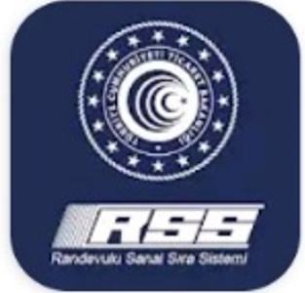

17 July 2020
General Directorate of Risk Management, Liquidation and Floating Capital

MOBILE APPLICATION OF VIRTUAL QUEUE SYSTEM WITH BOOKING (RSSS) MOBILE APPLICATION
(Application Steps)
1 | You can download the mobile application of the Virtual Queue System With Booking to your mobile phone, from Google Play store for mobile phones with Android operating systems; Also from Apple store for mobile phones with IOS operating system. | 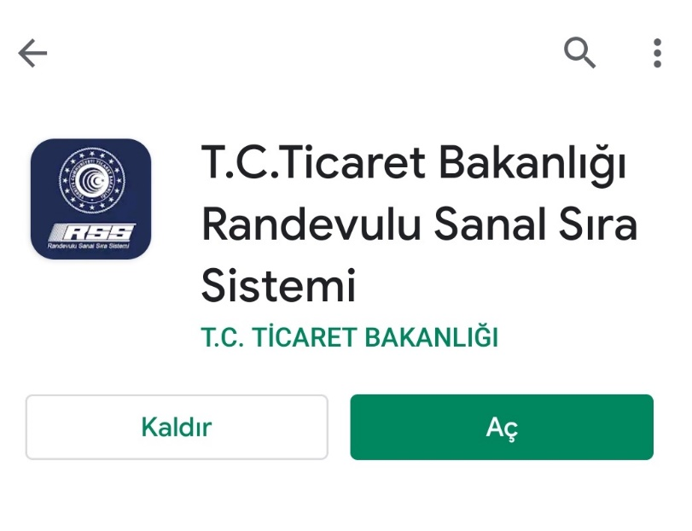
2 | Create the user registry. During registry please keep your identity number and your active mobile phone for sms verification. (Turkish citizens shall login with Turkish ID Number (TCKN), Foreign nationals shall login with Passport Number.)
3 | Press to “Make a Booking” button and select the load information of your vehicle as full or empty | 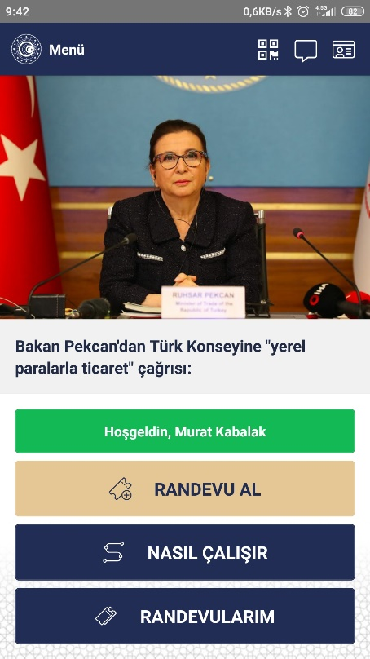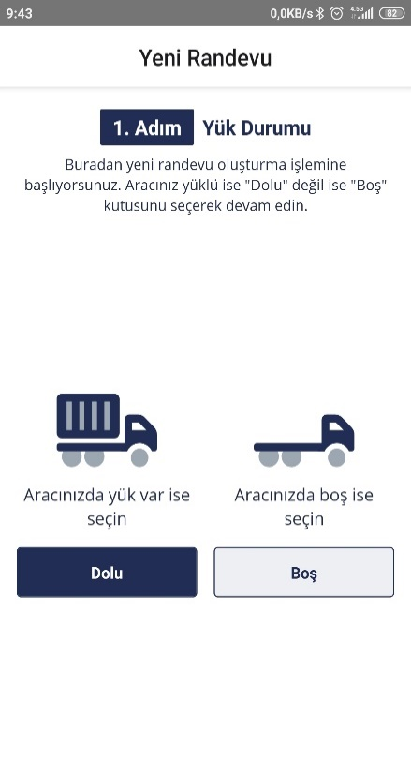
4 | Enter the transport document type and document number correctly in compliance with the BİLGE application | 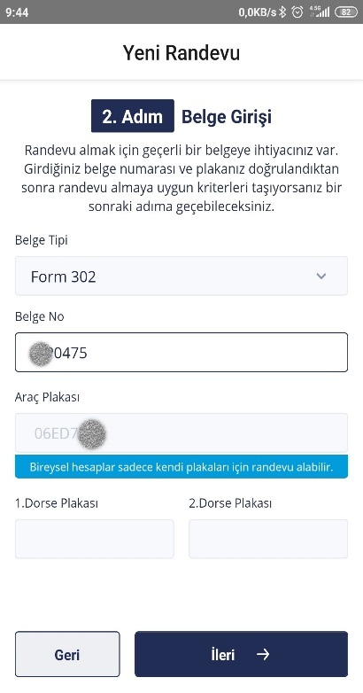
5 | Select the relevant options related with your load type/or any special circumstance about your status if there is any. | 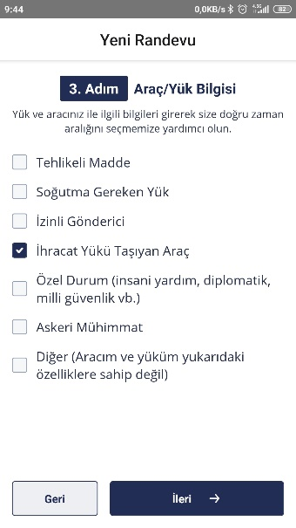
6 | Select the date that you are planning to exit the border and exact time that you will arrive to GTİ TIR Park. | 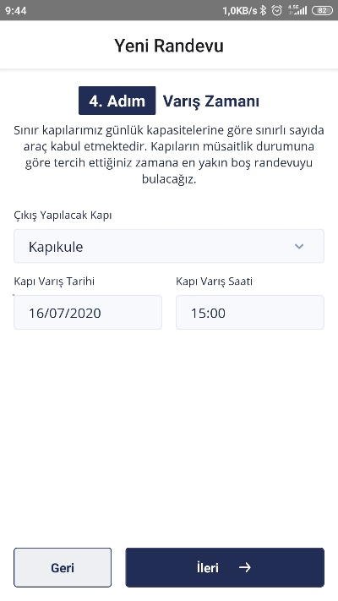
7 | There are time hourly slots in the system that state time intervals you estimate when to arrive to TIR Park and when to exit to the customs area (such as 14.00-15.00, 17.00-18.00). If the time interval which system assigned to you is suitable for you press the “Accept” button and enter the driver information.if not suitable press to “Change Date” button and select a suitable time interval (slot) for you. | 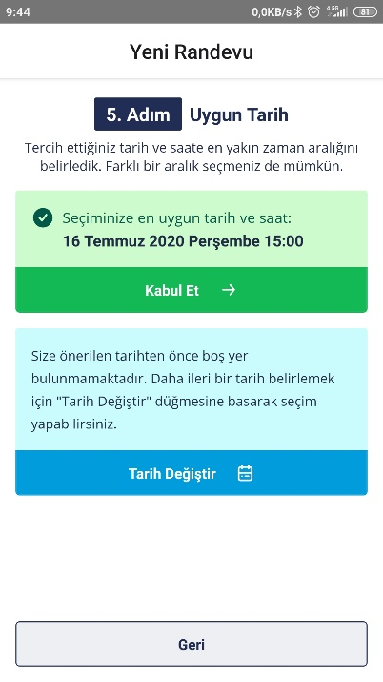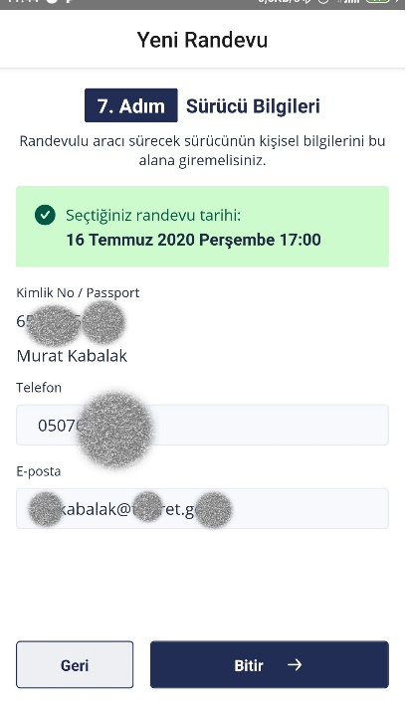
8 | Your booking is successfully created, by pressing “Display Ticket” button you can display the QR Code Screen. | 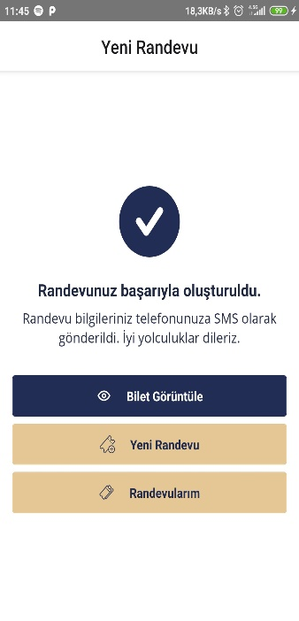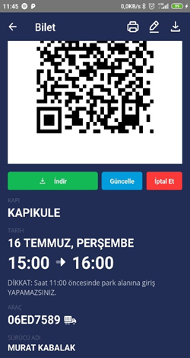
9 | Start driving forward to GTİ TIR Park.
10 | Your booking time is the time that you enter to GTİ Park. Please stick to this time.
11 | When you arrive to GTİ TIR Park, scan the QR Code at the mobile application to the entry control unit. If you have arrived in compliance with your booking time barrier will be opened.
12 | Inside the GTİ TIR Park, make a notification that you are ready to exit by pressing to “Ready for Exit” link received by SMS with your mobile phone (in the mobile application at the QR Code screen “Ready for Exit” button will be activated), or by pressing to the “Ready for Exit” button at the kiosks.
13 | Scan the QR code that you used to enter to the exit control unit. Move forward to the customs area when the barrier is opened.

